Subscribers Galore : Exploring World’s Top You Tube Channels



1. **INTRODUCION**

* 1. **Overview**

A subscriber to a channel on the video-sharing YouTube is a user who has chosen to receive the channel's content by clicking on that channel's "Subscribe" button, and each user's subscription feed consists of videos published by channels to which the user is subscribed. The ability to subscribe to users was introduced in October 2005. YouTube began publishing a list of its most- subscribed channels in April 2006. An early archive of the list dates to May 2006.

The following table lists the 50 most-subscribed YouTube channels, as well as the primary language and content category of each channel. The channels are ordered by number of subscribers; those whose displayed subscriber counts are identical are listed so that the channel whose current growth rate indicates that its displayed subscriber count will exceed that of the other channel is listed first. Automatically generated channels that lack their own videos (such as Music and News) and channels that have been made effectively obsolete as a result of the transferal of their content (such as Justin Bieber VEVO and Taylor Swift VEVO) are excluded. As of February 2023, 21 of the 50 channels listed primarily produce content in English while 16 primarily produce content in Hindi. All 50 of the channels have surpassed 40 million subscribers, 39 of them have surpassed 50 million subscribers, 23 of them have surpassed 60 million subscribers, 16 of them have surpassed 70 million subscribers, 12 of them have surpassed 80 million subscribers, 10 of them have surpassed 90 million and 7 of them have surpassed 100 million subscribers. Only 1 channel (T-Series) has surpassed 200 million subscribers.

* 1. **Purpose**

YouTube is a free video sharing website that makes it easy to watch online videos. You can even create and upload your own videos to share with others. Originally created in 2005, YouTube is now one of the most popular sites on the web, with visitors watching around 6 billion hours of video every month.

1. **PROBLEM DEFINITION & DESIGN THINKING**

* EMPATHY MAP
* BRAINSTROMING MAP

**2.1** **EMPATHY MAP**

* An empathy map is a collaborative tool teams can use to gain a deeper insight into their customers.
* Register the MURAL website to create the map
* In my term we are discussed and collect the details.

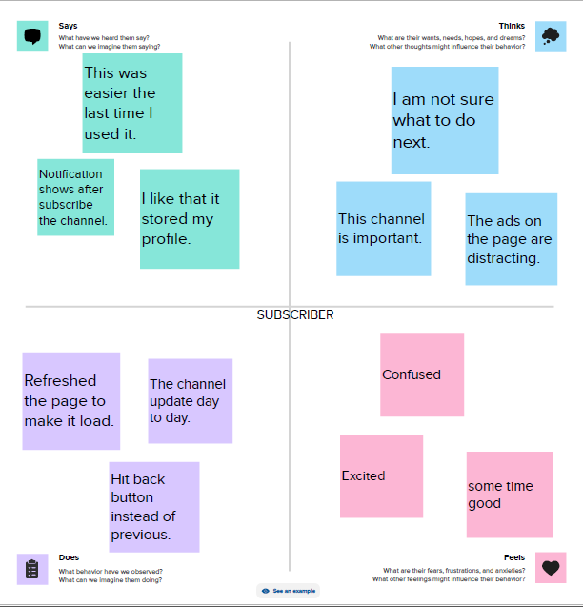

**2.2 BRAINSTORMING MAP**

* Brainstorming is a large or small group discussion that encourages students to generate a wide range of perspectives or potential next steps or solutions reading a specific topic.
* Use MURAL website to create.

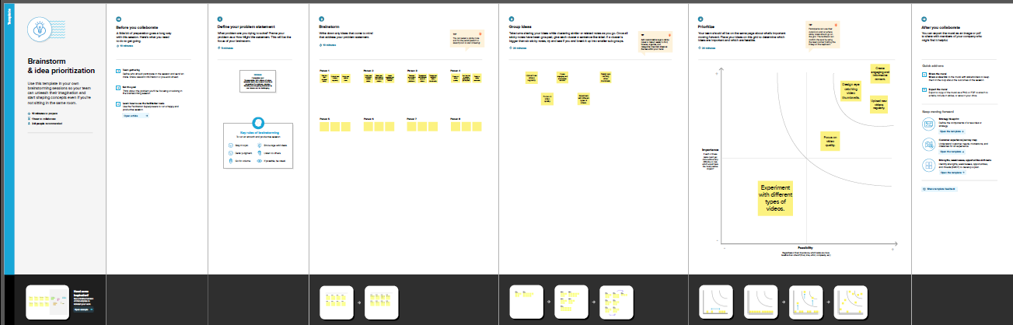

1. **RESULT**

* COLLECT THE DATASET
* CONNECT DATASET WITH TABLEAU

**3.1 COLLECT THE DATASET**

* We are collect the dataset in online.

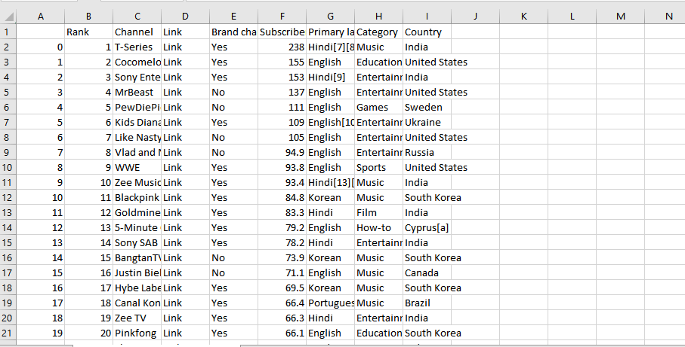

**3.2 CONNECT DATASET WITH TABLEAU**

* Installed the tableau desktop.
* Insert the dataset in tableau.

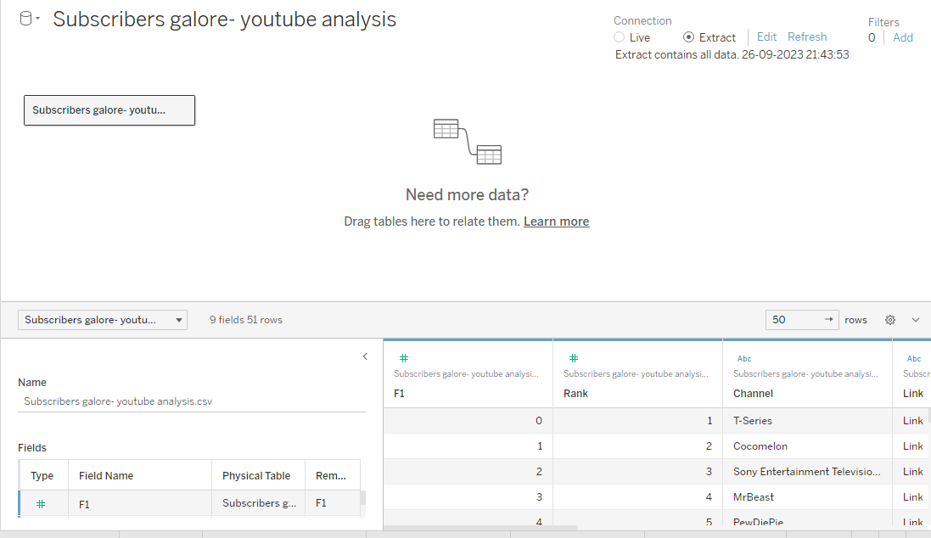

* DATA PREPARATION
* Prepare the data for visualization.
* We give the some changes for the dataset.
* DATA VISUALIZATION
* We introduced graphical representation to visualization.
* Rank wise Channel.
* No of Channels with Brand.
* Channel Brand.
* Channel name with subscribers.
* No of channels for particular language.
* Country wise subscribers.
* Language wise subscribers.
* Category wise language.
* Country wise language.
* Country wise Channel.
* Use this subheading to give the graphical visualization.
* Graphical representation like bar chart, pie chart, line chart and maps.
* DASHBOARD
* A dashboard is a graphical user interface (GUI) that displays information and data in an organized, easy to read format.
* Combine two or more sheets to create a dashboard.

**DASHBOARD 1**

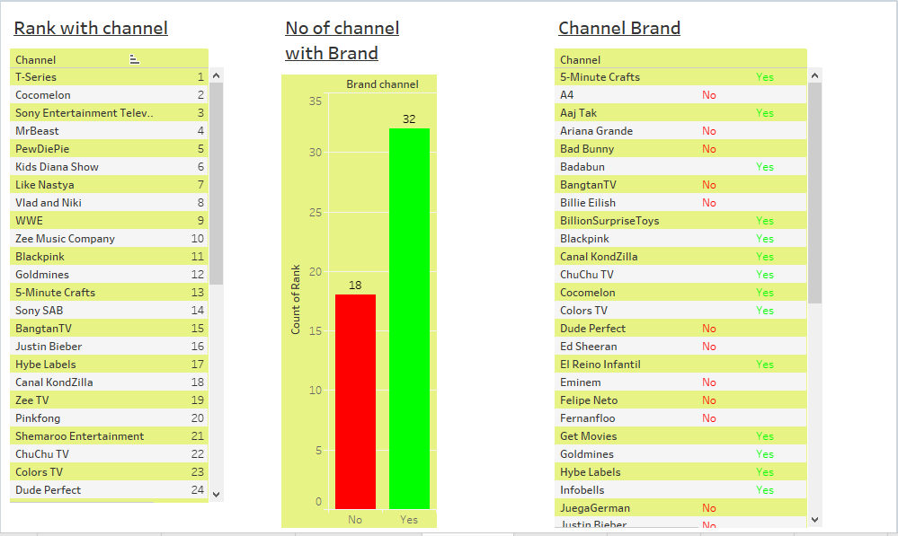

**DASHBOARD 2**

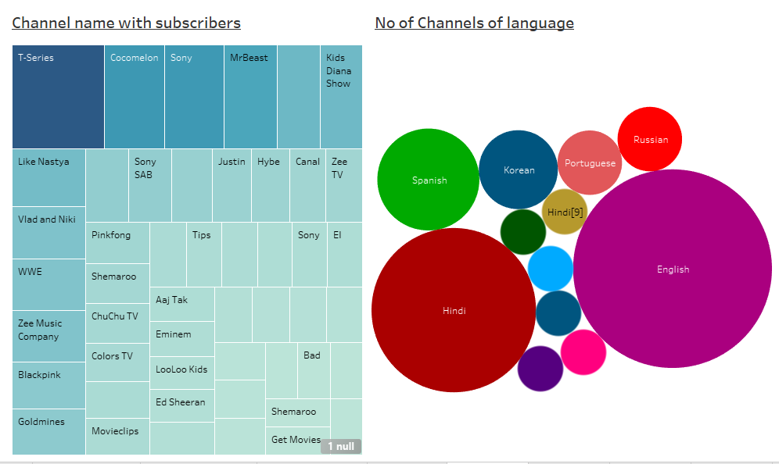

**DASHBOARD 3**

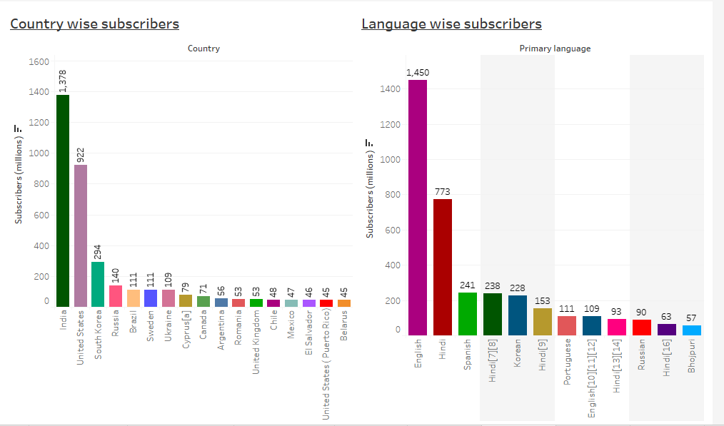

**DASHBOARD 4**

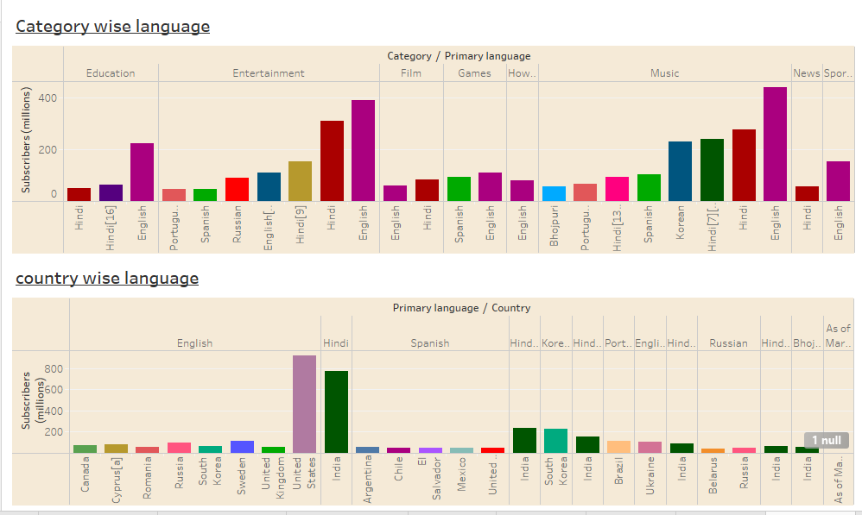

**DASHBOARD 5**

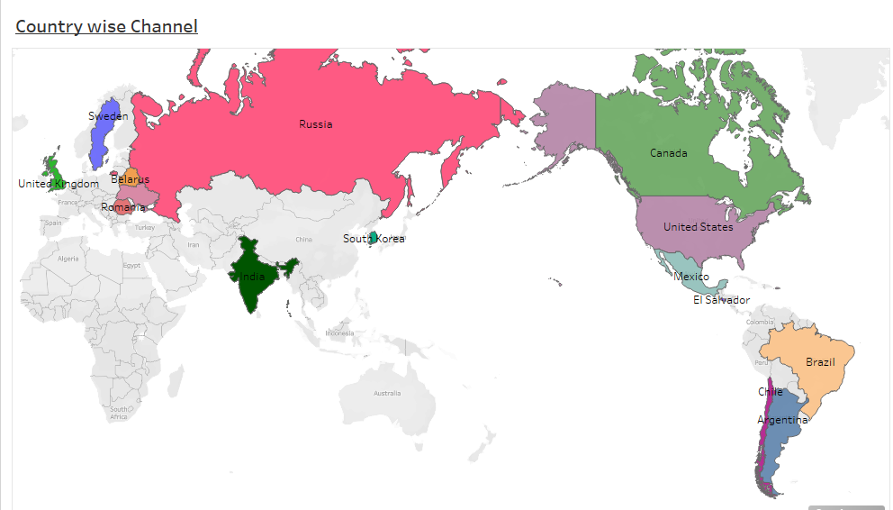

* Above our graphical representation are display.
* STORY
* Story gives clear introduction that sets the stages and explains the context for our data, a body that presents the data and analysis in a logical and systematic way and a conclusion that summarizes the key findings and highlights their implications.
* A storyboard is a visual representation of the data analysis process and it breaks down the analysis into a series of steps or scenes.

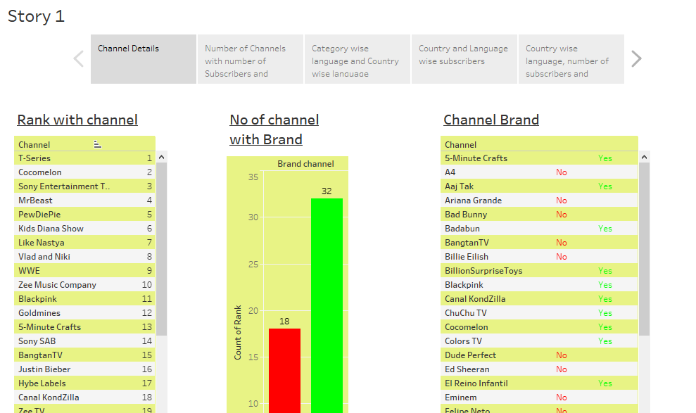

1. **ADVANTAGES & DISADVANTAGES**

* ADVANTAGES
* Free of cost.
* A simple way to share.
* Can earn money.
* Can connect more audience.
* DISADVANTAGES
* Vulgarity.
* Bullying and defamation.
* Earning money is difficult.
* Too much distraction.

1. **APPLICATIONS**

* You Tube is a very hug platform on which almost 300 hours of video uploaded every minute in the world. Now you can imagine amount of collection on You Tube. If you are looking for the solution of a problem starts with “how” “what” “where” “why” then you will get a visual solution on You Tube. Videos related to cooking, exercise, makeup, finance, news, music, meditation, study material, business etc… are available on this platform. Thinkers/motivational speakter are available on You Tube and upload their videos on You Tube on regular basis. Their videos might give you the solution

1. **CONCLUSION**

**OVERVIEW OF OUR PROJECT**

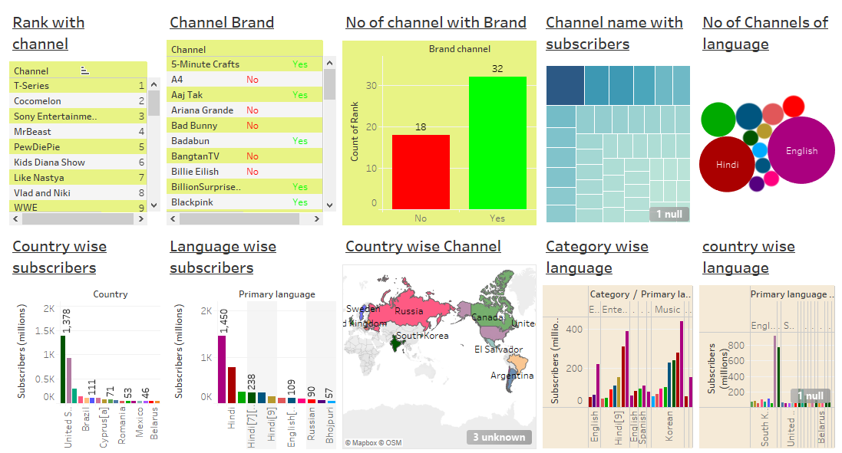

1. **FUTURE SCOPE**

* Overall, it’s challenging to predict precisely what the future holds for You Tube. Still, it’s likely that the platform will continue to evolve and adapt to changing user needs and technological developments, making it a central player in the online video space for years to come.

1. **APPENDIX**
2. Source Code

* DATASET LINK:

<https://drive.google.com/file/d/1jKlHK4Y7YlOLiqZkYpf9gYSuNgcjsKd_/view?usp=sharing>

* DASHBOARD 1 LINK:

<https://public.tableau.com/app/profile/keerthika.sangar/viz/DASHBOARD1_16964370016730/Dashboard1>

* DASHBOARD 2 LINK:

<https://public.tableau.com/app/profile/keerthika.sangar/viz/DASHBOARD2_16964375209660/Dashboard2>

* DASHBOARD 3 LINK:

<https://public.tableau.com/app/profile/keerthika.sangar/viz/DASHBOARD3_16964379925090/Dashboard3>

* DASHBOARD 4 LINK:

<https://public.tableau.com/app/profile/keerthika.sangar/viz/DASHBOARD4_16964384874220/Dashboard4>

* DASHBOARD 5 LINK:

<https://public.tableau.com/app/profile/keerthika.sangar/viz/DASHBOARD5_16964760500350/Dashboard4>

* STORY LINK:

<https://public.tableau.com/app/profile/keerthika.sangar/viz/story_16957123654380/Story1>